**Citrix Endpoint Analysis Plug-In Configuration**

**Prepared By**

**Virtuadesk**



Wipro Technologies

April2020

Copyright Acknowledgment

Any registered names, trademarks and logos used in this manual remain the property of the owning respective companies or organisations concerned.

This documentation may in whole or in part, be copied or replicated to any electronic medium for use within Wipro Technologies only. All copies that are made shall retain all copyright notices.

Disclaimer

The documentation is prepared based on the specifications and technical information specified or known to Wipro Technologies.

The contents Changes are periodically added to the information herein: these changes will be incorporated in subsequent version(s) of the documentation. Wipro may make improvements and / or changes in the documentation.

Trademark Acknowledgment

Wipro is a registered trademark of Wipro Limited.

***McAfee Live Safe***

If you are working from home on your personal/Office machines we request you to kindly download the free McAfee Antivirus and help us keep our corporate data safe by ensuring compliance to the Wipro security

This SOP describes on How to Login to MY-Connect Wipro VDI basis the latest changes that have taken place in Infrastructure after the Implementation of Endpoint Poisturing in My-Connect VDI Infra.

***Pre-requisites***

We urge you to kindly download the respective McAfee safe versions at the earliest.

WIPRO Laptop : Mcafee endpoint security – Version >= 10.5

Personal Laptop : Mcafee livesafe – Version >= 15.5

* After Installing Macfee Live Safe, browse your respective myconnect VDI url ex: bdc-myconnect.wipro.com

<https://bdc-myconnect.wipro.com>

<https://cdc-myconnect.wipro.com>

<https://hdc-myconnect.wipro.com>

<https://pdc-myconnect.wipro.com>

https//172.31.217.33/Citrix/BDCStoreWeb/ (For GATI Users)

***Citrix Endpoint Analysis Plug-In***

* When Windows users connect to Citrix Gateway using the browser for first time, the portal requests the installation of the Endpoint Analysis plug-in..
* The first time you access the system you will be asked to download software

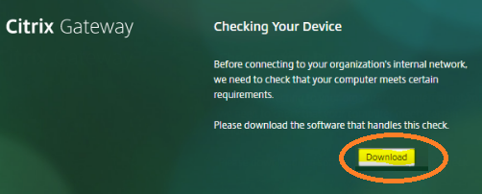

* Open and Run the auto generated setup file



* Click on Next/Install

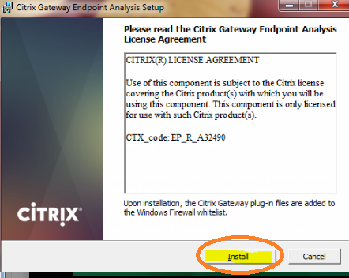

* Once installation is done –Click on finish

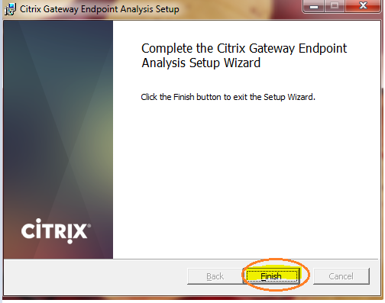

* Confirm Always or Yes. Priority is always

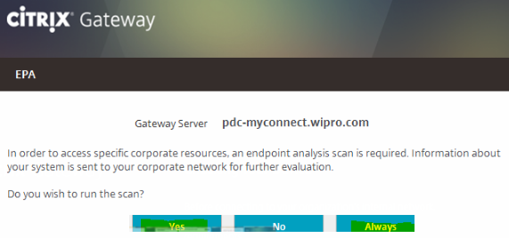

Don’t perform any action on below screen

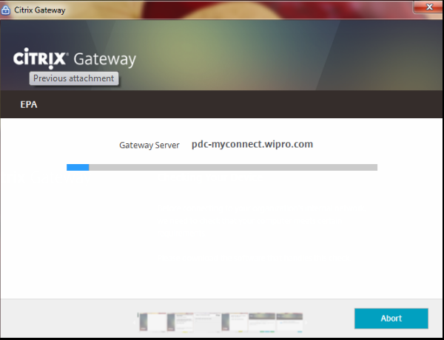

* It will route to Netscalar Gate way to start MFA login

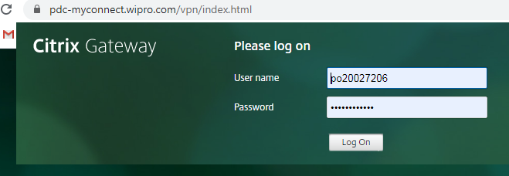

Username < Password < OTP <Submit < Virtuadesk VDI icon

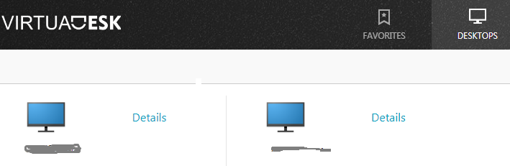

***Important Note***

On subsequent log on attempts, the plug-in checks the upgrade control configuration to decide if the client endpoint analysis plug-in upgrade is necessary.

If it is necessary, the user will receive a prompt to download and install the newer Endpoint Analysis plug-in